**Worksheet-2.2**

**Student Name**: Sahil Kaundal **UID:** 21BCS8197

**Branch**: CSE(LEET) **Section/Group:** 807/B

**Semester**: 4th **Date of Performance**: 25/03/2022

**Subject Name**: CN Lab **Subject Code:** 20CSP-257

1. **Aim/Overview of the practical:**

Create different network topologies like Star, Bus and Mesh Topology with the help of packet tracer and show the output.

1. **Task to be done/ Which logistics used:**

Create different network topologies like Star, Bus and Mesh Topology with the help of packet tracer and show the output.

1. **Steps for experiment/practical/Code:**

Star Topology:

* Connect different PCs with central hub/switches.
* Assign individual IPs to all PCs
* Drop PDU from one pc to another
* Start Simulation

Star topology is a network topology in which each network component is physically connected to a central node such as a router, hub or switch. In a star topology, the central hub acts like a server and the connecting nodes act like clients.

Bus Topology:

* All nodes are connected along with this communication line with two endpoints called the bus or backbone
* Connect PCs with switches serially.
* Drop PDU
* Start Simulation

Bus topology, also known as line topology, is a type of network topology in which all devices in the network are connected by one central RJ-45 network cable or coaxial cable. The single cable, where all data is transmitted between devices, is referred to as the bus, backbone, or trunk.

Mesh Topology:

* Every device has a dedicated (link carries traffic only between two devices) point to point link to every other device.
* Assign IPs to every individual Pc
* Drop PDU
* Start Simulation

In a mesh topology there is no central connection point. Instead, each node is connected to at least one other node and usually to more than one. Each node is capable of sending messages to and receiving messages from other nodes. The nodes act as relays, passing on a message towards its final destination.

1. **Result/Output/Writing Summary:**

Star Topology:

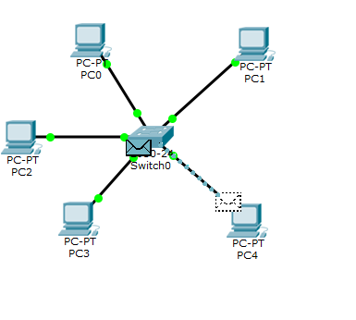

Bus Topology:

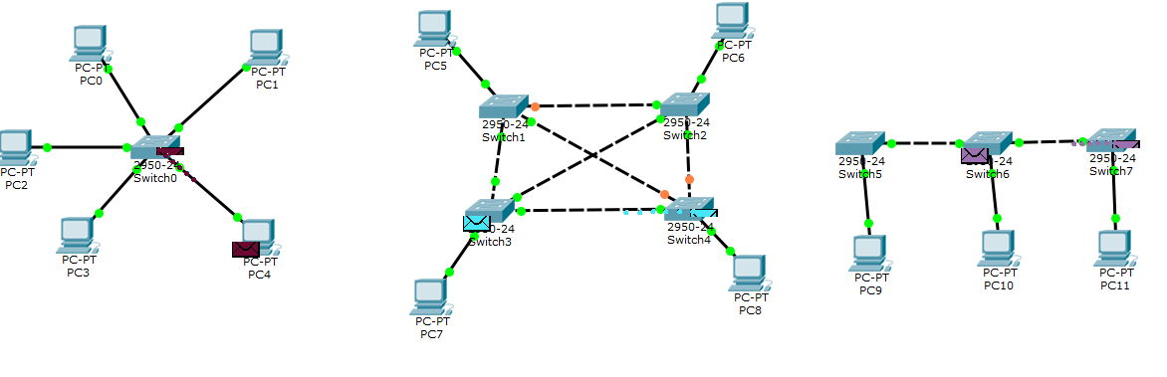

Mesh Topology:



**Simulation:-**

Star Topology:

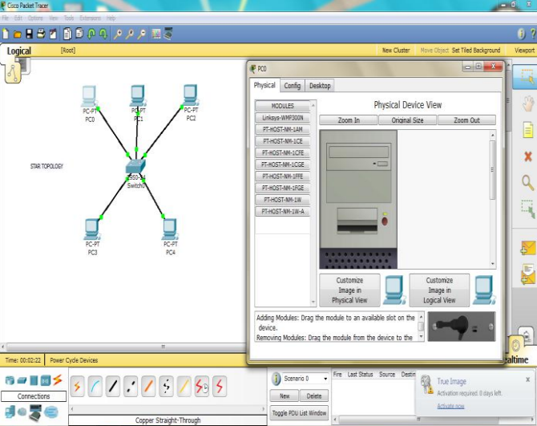

Bus Topology:

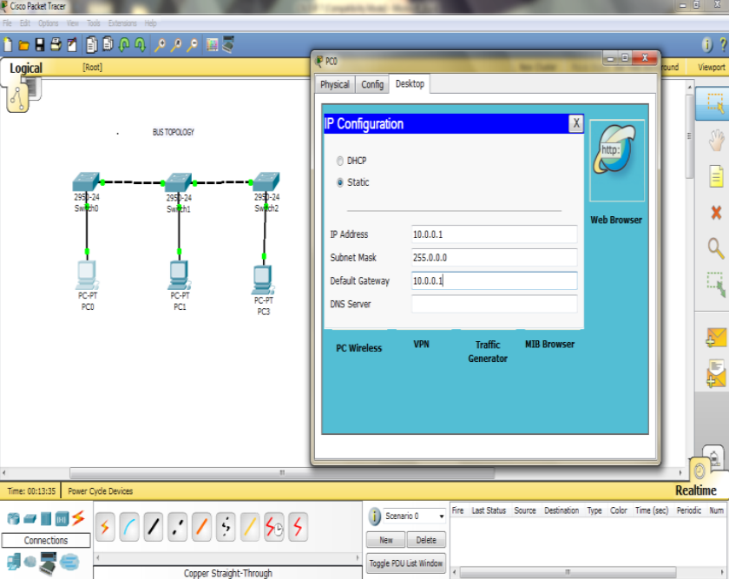

Mesh Topology:

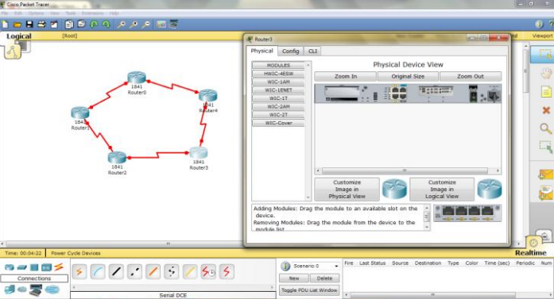

**Outcome:-**

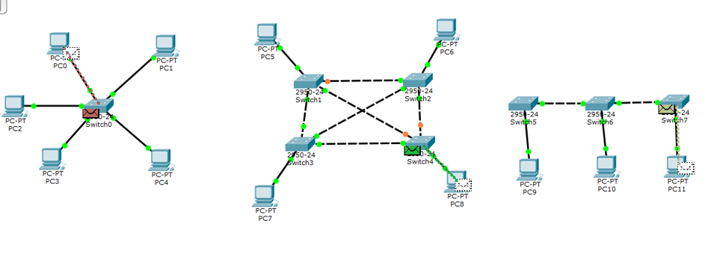

**Result:-**

I have successfully completed this experiment.

**Learning outcomes (What I have learnt):**

1. Working of Star, Mesh, Bus topology.
2. Created different network topologies like Star, Bus and Mesh Topology with the help of packet tracer.

**Evaluation Grid (To be created as per the SOP and Assessment guidelines by the faculty):**

|  |  |  |  |
| --- | --- | --- | --- |
| Sr. No. | Parameters | Marks Obtained | Maximum Marks |
| 1. |  |  |  |
| 2. |  |  |  |
| 3. |  |  |  |
|  |  |  |  |